Cite Your Sources
the EasyBib Way!

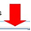
1. Go to www.easybib.com while at school. Click Register to create an account using your email address and a password you create. Now you will have access to all the premium services anywhere.

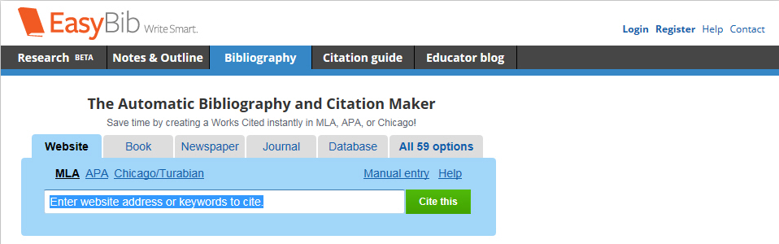

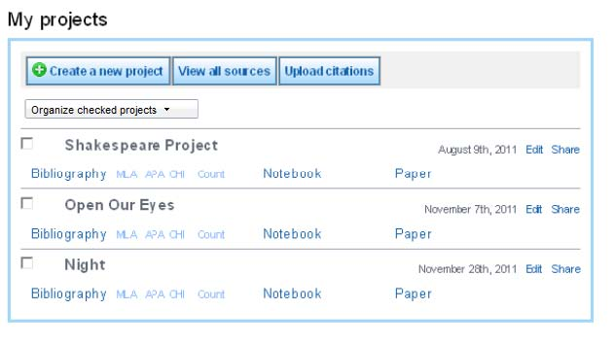

2. Click Create a new project and give your project a name. In most cases, leave MLA 7 selected.

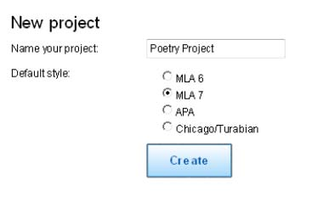

3. Click Bibliography under your new project title. Then click the tab for the type of source you need to cite. You can paste in the URL or book title and click Autocite, or choose Manual Entry.

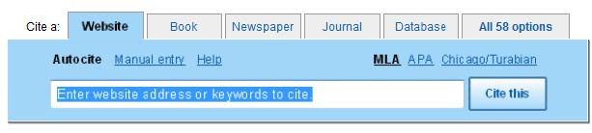

4. If you chose Autocite, some of the form may be filled out already. Review the information to make sure it’s correct, and enter any additional infor-mation required. Once you click the Create Citation button at the bottom of the form, your citation will be formatted correctly and saved as part of your bibliography.

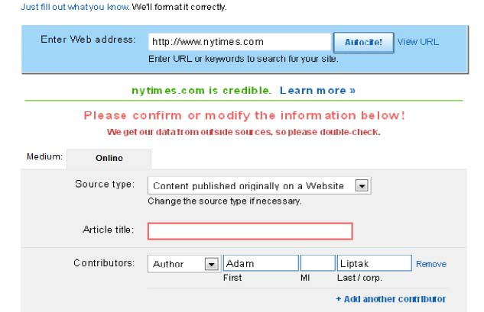
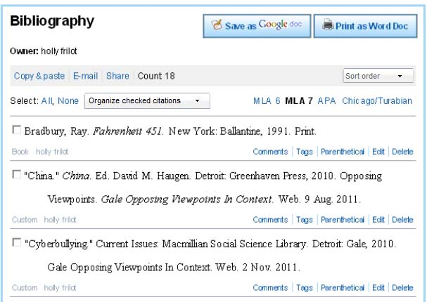

5. That’s it! Add more sources as you need. When you are done, you can Print as a Word doc and all your formatting will be correct. If you want to take notes, click the Notebook tab at the top of the page.

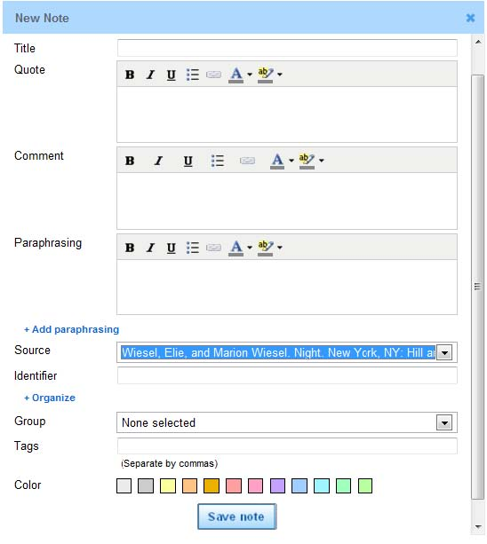
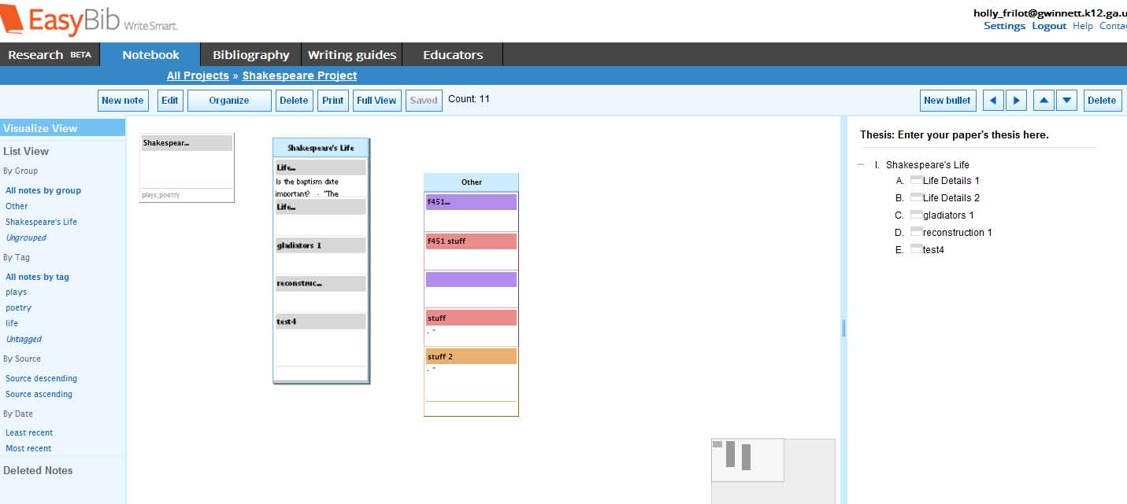
Stay organized with EasyBib’s online notecards

Once you’ve saved your notecard, it will appear on your virtual desktop (screenshot below). Here you can move and group your notes. You can also create an outline for your paper by dragging your notecards into the outline on the right side of the screen.

This is what your online notecard looks like. You can give your notecard a title, paste quotes, write your com-ments or thoughts, and even put information in your own words (paraphrase) directly on the notecard.

You can stay organized by connecting this note to a source you’ve already cited and adding tags (topics the note-card covers). You even have the option of color coding it!

You can print your notecards by click-ing the Print button on the virtual desktop.

