Lanier High School
Mrs. Lanio’s
AP Environmental Science (APES)

Dear future APES student,
Welcome! I hope you will have a great summer. To expand your mental frame of mind for APES, you have a summer assignment which consists of 3 parts:

1. Practice Math and Graphing Exercises WITHOUT A CALCULATOR. You cannot use a calculator on the AP exam, therefore you may not use a calculator in APES class. On the second day of school: 1 classwork grade for the math practice exercises, 1 classwork grade for the graphing exercises; 1 test grade on the second week of school (combined math, legislation and reading reflections test).

2. Environmental Legislation is an important part of APES and the AP exam. Therefore you will research 12 laws and state their objectives. One the second day of school: 1 classwork grade for the objectives of the Environmental Legislation; 1 test grade on the second week of school (combined math, legislation and reading reflections test).

For the following list of laws, state the main objective of each law.
1 and 2) Clean Air Act (CAA) of 1970, and CAA of 1990
3) Clean Water Act (CWA) of 1972
4) Comprehensive Environmental Response, Compensation, and Liability Act (CERCLA or Superfund), 1980
5) Endangered Species Act (ESA) of 1973
6) Federal Insecticide, Fungicide and Rodenticide Act (FIFRA), 1947
7) Hazardous and Solid Waste Amendments (HSWA) of 1984
8) Occupation Safety and Health Act of 1970 (OSH Act)
9) Resource Conservation and Recovery Act (RCRA) of 1976
10) Safe Drinking Water Act (SDWA) of 1974
11) Toxic Substances Control Act (TSCA) of 1976
12) Wilderness Act of 1964

3. Reading Reflections about Environmental Issues in current/recent books and then summarizing what you read. Reading and writing are essential components of higher education, and therefore, we do a GREAT DEAL of it in APES. One the second day of school: 1 classwork grade for HANDWRITTEN notes you made about the book. Be prepared to take a test on the big ideas of the book on the second week of school. You can use HANDWRITTEN NOTES ONLY on this test.

The book is called “Visit Sunny Chernobyl: And Other Adventures in the World's Most Polluted Places” by Andrew Blackwell. You can get this book at the local library, buy it from your local bookstore, or Amazon. It may also be available as audiobooks on audible.com or as e-books/kindle books if you have an e-reader.

As you read the book take handwritten notes that you were:
- Impressed by
- You thought were controversial
- You found to be ignorant/baseless/weak arguments
- Take notes on how it ties with one or more of the subjects covered in APES: Population, Ecology, Water (Resources & Pollution), Agriculture/Soils, Pesticides, Air Pollution, Biodiversity, Waste and Conservation, Health Hazards and/or Urbanization.

You must bring your work with you on the first day of school. If you have any questions concerning these tasks, please email me or if you have any questions about the course you can also email me:
Jeannie_Lanio@gwinnett.k12.ga.us

Decimals
Directions: remember to show all your work, include units if given, and NO CALCULATORS! All work and answers go on your answer sheet.
- 1.678 + 2.456 =
- 344.598 + 276.9 =
- 1229.078 + .0567 =
- 45.937 – 13.43 =
- 199.007 – 124.553 =
- 90.3 – 32.679 =
- 28.4 x 9.78 =
- 324.45 x 98.4 =
- 1256.93 x 12.38 =
- 64.5 / 5 =
- 114.54 / 34.5 =
- 3300.584 / 34.67 =

Averages
Directions: to find the average, add all the quantities given and divide the total by the number of quantities
- Find the average of the following numbers: 11, 12, 13, 14, 15, 23, and 29
14. Find the average of the following numbers: 124, 456, 788, and 343
15. Find the average of the following numbers: 4.56, .0078, 23.45, and .9872

Percentages
16. What is 45% of 900?

17.Tthirteen percent of a 12,000 acre forest is being logged. How many acres will be logged?

18. A water heater tank holds 280 gallons. Two percent’s of the water is lost as steam. How many gallons remain to be used?

19. What percentage is 25 of 162.5?

20. 35 is the percentage of 2,800?

21. 14,000 acres of a 40,000 acre forest burned in a forest fire. What percentage of the forest was damaged?

22. You have driven the first 150 miles of a 2,000 mile trip. What percentage of the trip have you traveled?

23. Homes prices have dropped 5% in the past three years. An average home in Indianapolis three years ago was $130,000. What’s the average home price now?

24. The Greenland ice sheet contains 2,850,000 cubic kilometers of ice. It is melting at a rate of .006% per year. How many cubic kilometers are lost each year?

25. 235 acres, or 15%, of a forest is being logged. How large is the forest?

26. A teenager consumes 20% of her calories each day in the form of protein. If she is getting 700 calories a day from protein, how many calories is the consuming per day?

27. In a small oak tree, the biomass of insects makes up 3,000 kilograms. This is 4% of the total biomass of the tree. What is the total biomass of the tree?

Metric Units
28. 1200 kilograms =? milligrams
29. 14000 millimeters =? meters
30. 670 hectometers =? centimeters
31. 6544 liters =? milliliters
32. .078 kilometers =? meters
33. 17 grams =? kilograms

SCIENTIFIC NOTATION
Write the following numbers in scientific notation:
34. 145,000,000,000
35. 13 million
36. 435 billion
37. .000348
38. 135 trillion
39. 24 thousand

Complete the following calculations:
40. 3x10³+4x10³
41. 4.67x10⁴+323x 10³
42. 7.89 x 10⁻⁶ + 2.35 x 10⁻⁸
43. 9.85 x 10⁴- 6.35 x 10⁴
44. 2.9 x 10¹¹ -3.7 x 10¹³
45. 1.278 x 10⁻¹³ -1.021 x 10⁻¹⁰
46. three hundred thousand plus forty-seven thousand
47. 13 million minus 11 thousand
48. 1.32 x 10⁸ x 2.34 x 10⁴
49. 3.78 x 10³ x 2.9 x 10²
50. three million times eighteen thousand
51. eight ten–thousands of thirty-five million
52. 3.45 x 10⁹ / 2.6 x 10³
53. 1.98 x 10⁻⁴ / 1.72 x 10⁻⁶
54. twelve thousand divided by four thousand

Dimensional Analysis
Use scientific notation when appropriate
Conversions:
1 square mile= 640 acres
1 hectare (Ha) = 2.47 acres
1 kw-hr =3,413 BTUs
1 barrel of oil = 159 liters
1 metric ton = 1000 kg

55. 134 miles = ? inches

56. 8.9 x 10 ⁵ tons =? ounces

57. 1.35 kilometers per second =? miles per hour

58. A city that uses ten billion BTUS of energy each month is using how many kilowatt-hours of
energy?

59. A 340 million square mile forest is how many hectares?

60. If one barrel of crude oil provides six million BTUs of energy, how many BTUs of energy will
one liter of oil provide?

AP Environmental Science Graph Prep
Part 1: Practice Interpreting Data:

1. Identify the graph that matches each of the following stories:
a. I had just left home when I realized I
had forgotten my books so I went back to
pick them up
b. things went fine until I had a flat tire.
c. I started out calmly, but sped up when I
realized I was going to be late.

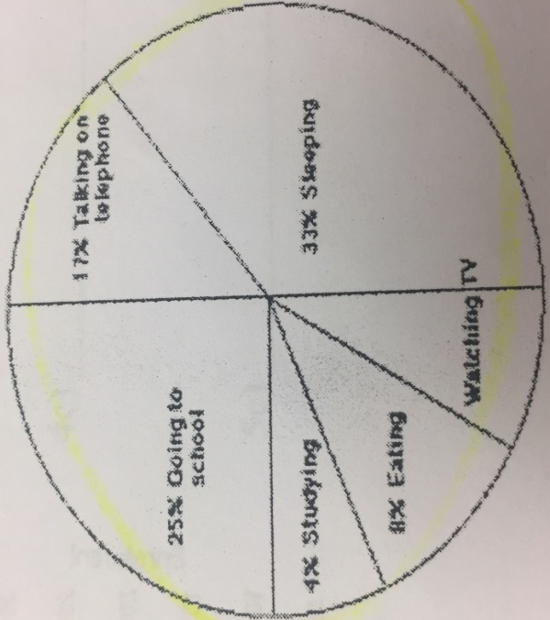
2. The graph at the right represents the typical day of a teenager.
Answer these questions:
- What percent of the day is spent watching TV?
- How many hours are spent sleeping?
- What activity takes up the least amount of time?
- What activity takes up a quarter of the day?
- What two activities take up 50% of the day?
- What two activities take up 25% of the day?

3. Answer these questions about the graph below:
a. How many sets of data are represented?
b. On approximately what calendar date does the graph begin?
c. In what month does the graph reach its highest point?

4. Answer these questions about the graph below:
a. What is the dependent variable on this graph?
b. Does the price per bushel always increase with demand?
c. What is the demand when the price is 5$ per bushel?

5. The bar graph below represents the declared majors of the freshmen enrolling at a university. Answer the following questions:
a. What is the total freshmen enrollment of the college?
b. What percent of the students are majoring in physics?
c. How many students are majoring in economics?
d. How many more students major in poly sci than in psych?
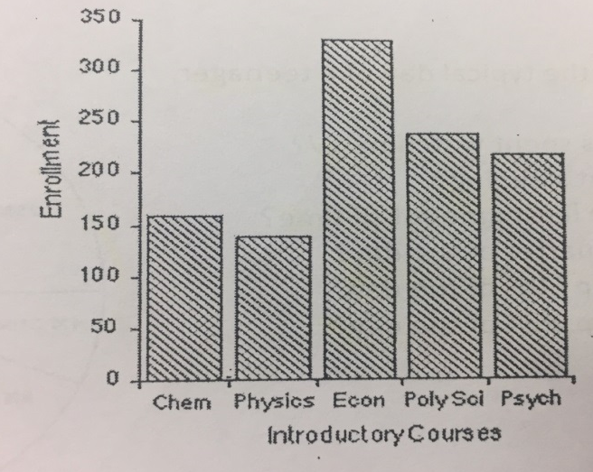

Part 2: Practice Making Graph:
- Identify the variables. The independent variable is controlled by the experimenter. The dependent variable changes as the independent variable changes. The independent variable will go the X axis and the dependent on the y axis.
- Determine the variable range. Subtract the lowest data vale from the highest data value.
- Determine the scale of the graph. The graph should use as much of the available space as possible. Each line of the scale must go up in equal increments. For example, you can go 0, 5, 10, 15, 20, etc. but you cannot go 1, 3, 9, 34, 50, etc. Increments of 1, 2, 5, 10, or 100 are commonly used but you should use what works best for the given data.
- Number and label each axis.
- Plot the data. If there are multiple sets of data on the graph, use a different color for each.
- Make a line graph of the data.
- Title the graph. Titles should explain exactly what graph is showing and are sometimes long. Don’t be afraid of a long title!!!
- Create a key to graph if there is more than one set of data.

Problem 1
Age of the tree in years | Average thickness of the annual rings in cm.  Forest A | Average thickness of the annual rings in cm.  Forest B
10 | 2.0 | 2.2
20 | 2.2 | 2.5
30 | 3.5 | 3.6
35 | 3.0 | 3.8
50 | 4.5 | 4.0
60 | 4.3 | 4.5

The thickness of the annual rings indicates what type of environmental situation was occurring at the time of its development. A thin ring, usually indicates a rough period of development. Lack of water, forest fires, or a major insect infestation. On the other hand, a thick ring indicates just the opposite.
- Make a line graph of the data
- What is the dependent variable?
- What is the independent variable?
- What was the average thickness of the annual rings of the 40-year-old trees in forest A?
- Based on this data, what can you conclude about Forest A and Forest B?

Problem 2
pH of water | Number of tadpoles
8.0 | 45
7.5 | 69
7.0 | 78
6.5 | 88
6.0 | 43
5.5 | 23

- Make a line graph of the data.
- What is the dependent variable?
- What is the independent variable?
- What is the average pH in this experiment?
- What is the average number of tadpoles per sample?
- What is the optimum water pH tadpole development?
- Between what two pH readings is there the greatest change in tadpole number?
- How many tadpoles would you expect to find in water with a pH reading of 5.0?

Please only print out and turn in pages 9-17
double sided when you come to class.

Mrs. Lanio
Summer Assignment: Reading Reflections Date:___________________

Your Book:________________________________________________

1. Review the notes you took and skim through the book you read this summer.
2. Find and record (in the left hand column) 5 subjects covered in APES (see assignment instructions) that you think are the most important from the entire book.
3. Record your reflections for each of your subject areas. For example, Subject:Water Pollution
Your Reflection: the water pollution in the River Ganges in India is affecting the health of the people especially that it is part of their culture etc… Describe the importance of this area and what are the positive and negative effects. Describe how the book may connect to your personal life, or to what you heard on the news over the last few months/years that worries/elates/scares you.
 | Subjects covered in APES | Your Reflection (Write legibly)
1

2

APES
Mrs. Lanio
Summer Assignment: Reading Reflections Date:___________________
 | Subjects covered in APES | Your Reflection (Write legibly)
3
4
5
Think and write your reflections carefully. You can use this sheet on the test.
Decimals
1. |  | 2. |  | 3.
4. |  | 5. |  | 6.
7. |  | 8. |  | 9.
10. |  | 11. |  | 12.

Averages
13. |  | 14. |  | 15.
Percentages
16. |  | 17. |  | 18.
19. |  | 20. |  | 21.
22. |  | 23. |  | 24.
25. |  | 26. |  | 27.
Metric Units
28. |  | 29. |  | 30.
31. |  | 32. |  | 33.

Scientific Notation
34. |  | 35. |  | 36.
37. |  | 38. |  | 39.
40. |  | 41. |  | 42.
43. |  | 44. |  | 45.
46. |  | 47. |  | 48.
49. |  | 50. |  | 51.
52. |  | 53. |  | 54.

Dimensional Analysis
55. |  | 56. |  | 57.
58. |  | 59. |  | 60.

PART 1: Practice Interpreting Data
1a. |  | 1b. |  | 1c.
2a. |  | 2b. |  | 2c.
2d. |  | 2e. |  | 2f.
3a. |  | 3b. |  | 3c.
4a. |  | 4b. |  | 4c.
5a. |  | 5b. |  | 5c.
5d.

Part 2: making graphs
1a.

1b. |  | 1c. |  | 1d

1e.

Problems 2
2a.
2b. |  | 2c. |  | 2d.
2e. |  | 2f. |  | 2g.
2h.

Main Objective
CAA1970
CAA1990
CWA 1972
CERCLA
1980
ESA
1973
FIFRA
1947

Main Objective
HSWA
1984
OSH1970
RCRA 1976
SDWA
1974
TSCA
1976
Wilderness
Act 1964

